NIKRF – Case for Support Form
Research Support Grants
________________________________________
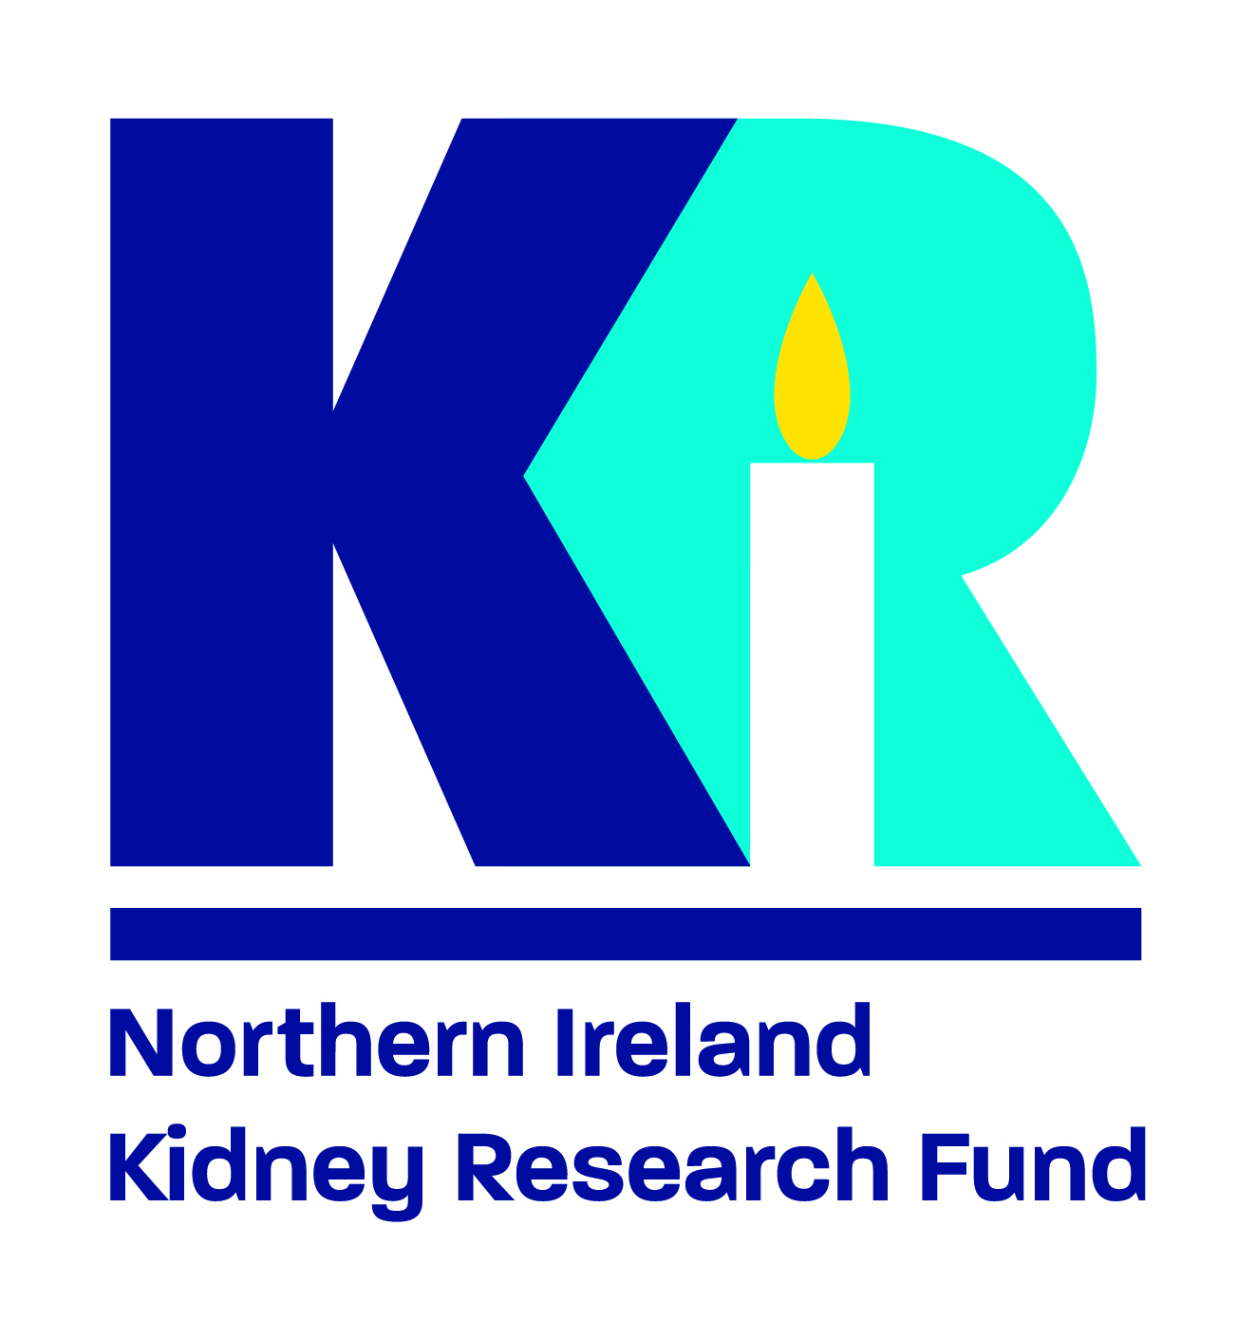
________________________________________
Applying for Funding
- Applications for funding from the NIKRF are open to people undertaking renal research in Northern Ireland.
- Applications for funding >£5000 from the NIKRF involve submission of a case for support form and a proposal presentation to NIKRF advisors at a monthly Renal Research in Progress Meeting.
- Following submission of a case for support and presentation at the Renal Research in Progress Meeting, the medical advisors to NIKRF will make a funding recommendation to NIKRF.
- Recipients of funding from NIKRF will be expected to engage with patient and public involvement.
- All presentations of funded research must include the NIKRF logo and acknowledge the support received.
- The research may be asked to be presented at an NIKRF meeting.
- NIKRF must be notified of any presentations or publications resulting from the work undertaken. Acknowledgment of funding must be included in publications.

Submission of Case for Support
- The case for support form should be saved as a PDF file for submission.
- Submit the file by email to Susan Kee s.kee@qub.ac.uk
- Where relevant, any supervisors, co-applicants or collaborators on the project should be cc’d into the submission email.
- The applicant must also submit a CV (maximum 2 pages) with 200-word biography and photo. The biography and photo will appear on NIKRF website.
- In addition to the case for support and CV, a full breakdown of research costs should be calculated by a finance department and submitted also.
- If you have not done so already, please arrange a date to present your proposal at a Renal Research in Progress Meeting by contacting the NIKRF Research Operations Manager by email to s.kee@qub.ac.uk

 | Applicants should try to adhere to the given layout. The form should be completed in Arial font size 11pt and single line spacing.
1 | APPLICANT’S DETAILS
 | Name (including title)
 | Professional Background
Professional Registration
(if applicable)
 | Current Job Title
2 |  | EMPLOYMENT DETAILS & APPLICANT CORRESPONDENCE
 |  | The correspondence details are the only means by which the NIKRF can communicate with the applicant. Please provide a valid correspondence address, with up-to-date telephone and email details.
 |  | Employing Organisation
 |  | Department
 |  | Address
 |  | Postcode
 |  | E-mail
 |  | Telephone/Mobile no.

3 | Describe the project title, background to the project, clearly state your aim, and proposed objectives, and describe your research plan including methods. (800 words max)

4 |  |  | Clearly define the anticipated outcomes including research outputs within the timescale of your project. (400 words max)
5 |  |  | Detail plans for obtaining ethical approval for the project (if applicable) including detailed timelines) (400 words max)
6 |  |  | Describe any previous work (including publications) or existing data supporting the project. (800 words max)
7 |  |  | Provide justification for the funding support requested. (800 words max)
8 |  | Details of Main Supervisor (if applicable) or co-applicant (if applicable)
Name
Position/Institution

Address
Postcode
Email
Telephone
Degree undertaken (if applicable) |  |  |  |  |  | Anticipated start date
 | PLEASE SUBMIT APPLICATION, CV (MAX. 2 PAGE) AND RESEARCH COSTINGS TO:
 | Susan Kee by email to: s.kee@qub.ac.uk
 | Has this work been presented at the Renal Research in Progress Meeting?
 | If yes, on what date?
 | If no, what date is presentation planned?
References

